Clock
This section will provide details about the Clock features build into the BUG mod. Here is a screenshot of the options screen:
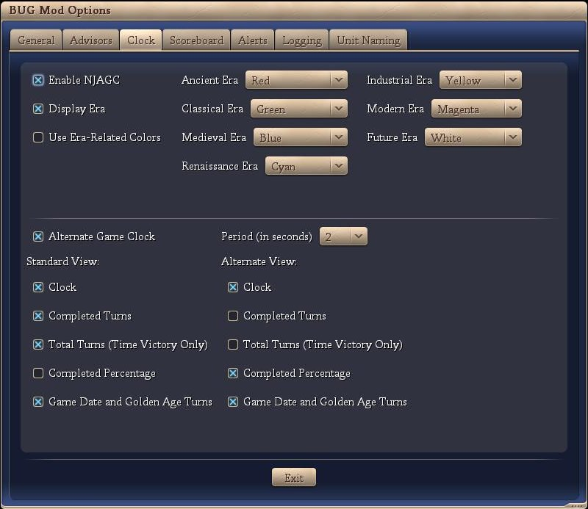
The individual Clock features are discussed below:
- Enable NJAGC (Not Just Another Game Clock)
If this option is checked then the Clock portion of BUG is enabled.
- Display Era
If checked, then the current era (according to the player) is displayed.
- Use Era-Related Colors
If checked, then the current era (according to the player) is displayed in the color that the user can specify (drop downs to the right).
- Alternate Game Clock
If checked, then the clock alternates between ‘Standard View’ and ‘Alternate View’. The user can specify the alternating time period in seconds. If not checked, only the ‘Standard View’ is displayed.
- Standard / Alternate View(s)
  - Clock
If checked, the time is displayed
  - Completed Turns
If checked, the time is displayed
  - Total Turns (Time Victory Only)
If checked, the total turns for this game are displayed.
  - Completed Percentage
If checked, the percent complete (as measured by turns) is displayed.
  - Game Date and Golden Age Turns
If checked, the game date and Golden Age turns are displayed.

The following is a sample screen shot showing the Standard View.

The following is a sample screen shot showing the Alternate View.

Conclusion
Opinion: It is our opinion that no additional information is presented to the user via this section of the BUG mod and it should be approved.

